Debris Graphs

2023-01-09

library(tidyverse)

## ── Attaching packages ─────────────────────────────────────── tidyverse 1.3.2 ──  
## ✔ ggplot2 3.4.0 ✔ purrr 1.0.0   
## ✔ tibble 3.1.8 ✔ dplyr 1.0.10  
## ✔ tidyr 1.2.1 ✔ stringr 1.5.0   
## ✔ readr 2.1.3 ✔ forcats 0.5.2   
## ── Conflicts ────────────────────────────────────────── tidyverse_conflicts() ──  
## ✖ dplyr::filter() masks stats::filter()  
## ✖ dplyr::lag() masks stats::lag()

library(readxl)  
library(plotrix)  
macroplastics <- read_excel("~/Desktop/MB5001 Macroplastics Counts.xlsx")  
plastics_mass <- read_excel("~/Desktop/MB5001 Macroplastics Mass.xlsx")

plastics_summary <- macroplastics %>%   
 group_by(Tidal_line, Site) %>%   
 summarise(mean = mean(Count), std_error = std.error(Count))

## `summarise()` has grouped output by 'Tidal_line'. You can override using the  
## `.groups` argument.

plastics_summary$Tidal_line = factor(plastics_summary$Tidal_line, levels = c('Water', 'Low tide line', 'High tide line', 'Vegetation line', 'Grassy area'))

ggplot(plastics_summary, aes(x = Tidal_line, y = mean)) +  
 geom_bar(stat = "identity") +  
 geom_errorbar(aes(ymin = mean - std_error, ymax = mean + std_error), width = 0.4, size = 0.4) +  
 labs(x = "Sampling height", y = "Mean debris count per site (+/- SE)") +  
 facet_wrap(~ Site) +  
 theme_classic() +  
 theme(axis.text.x = element_text(angle = 90))

## Warning: Using `size` aesthetic for lines was deprecated in ggplot2 3.4.0.  
## ℹ Please use `linewidth` instead.

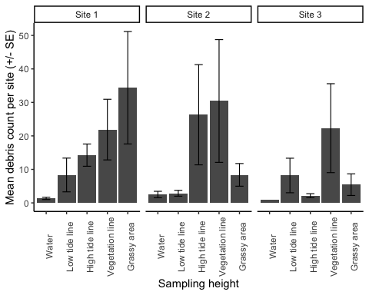

plastics_mass$Tidal_line = factor(plastics_mass$Tidal_line, levels = c('Water', 'Low tide line', 'High tide line', 'Vegetation line', 'Grassy area'))

ggplot(plastics_mass, aes(x = Tidal_line, y = Total_weight_kg)) +  
 geom_bar(stat = "identity") +  
 facet_wrap(~ Site) +  
 theme_classic() +  
 theme(axis.text.x = element_text(angle = 90)) +  
 labs(x = "Sampling height", y = "Total weight of debris (kg)")

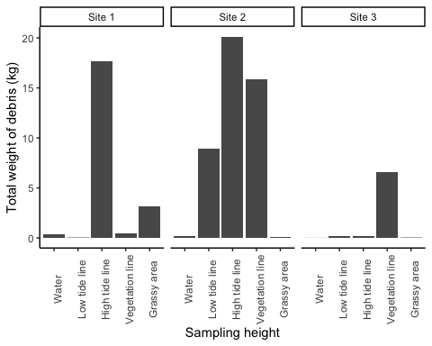

macroplastics$Tidal_line = factor(macroplastics$Tidal_line, levels = c('Water', 'Low tide line', 'High tide line', 'Vegetation line', 'Grassy area'))

macroplastics %>%   
 ggplot() +  
 geom_bar(mapping = aes(fill = material, x = Tidal_line), na.rm = T, position = "fill") +  
 theme_classic() +  
 labs(x = "Sampling height", y = "Proportion of debris", fill = "Debris material") +  
 theme(axis.text.x = element_text(angle = 90))

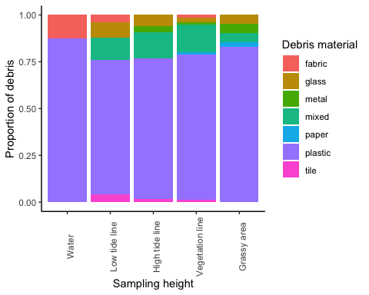

macroplastics %>%   
 ggplot() +  
 geom_bar(mapping = aes(fill = category, x = Tidal_line), na.rm = T, position = "fill") +  
 theme_classic() +  
 labs(x = "Sampling height", y = "Proportion of debris", fill = "Source of debris") +  
 theme(axis.text.x = element_text(angle = 90))

